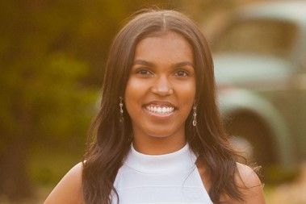  From sophomore to senior year, I was fortunate to be a part of the Delta GEMS program. The opportunity I had to create a bond with not only other African American teenagers but also predominant African American women in the Seattle area is  one I would not trade for the world. Being a GEM for the past three years has pushed me to think deeper and work harder all while having fun. The  community put forth by the Delta GEMS program is one which every young African American female should have because it shows there's other women who are going through or have gone through a similar situation and at the end of the day, they want to help you. Delta GEMS truly embodies the  meaning of sisterhood.  Kyla Marks,  2018 graduating GEM  Awardee of Seattle Alumnae Chapter’s Bertha Pitts Campbell Scholarship | 2018-19 GEMS  gem  The Seattle Alumnae Chapter of Delta Sigma Theta Sorority, Inc. has served King, Kitsap, & Snohomish Counties since 1933.  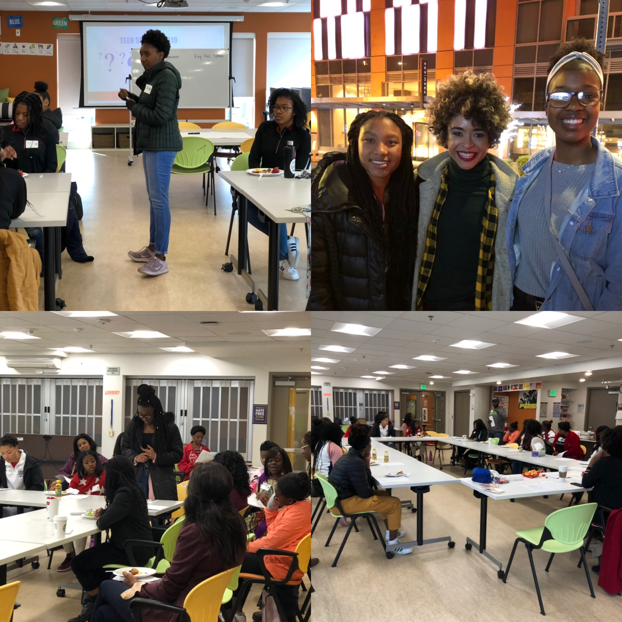  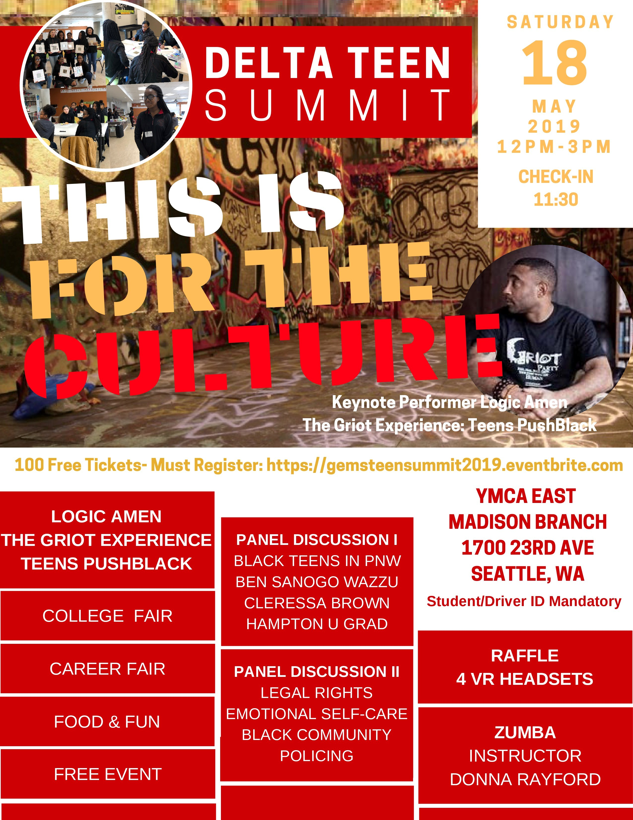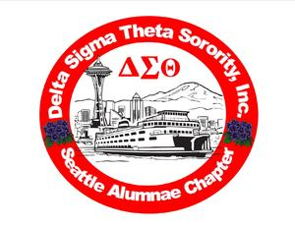 |  | G.E.M.S.  Growing and Empowering  Myself Successfully  The GEMS attended a Broadway musical- Hip Hop Nutcracker; went ice-skating, planned, marketed and facilitated a TEEN SUMMIT for their peers. They created vision boards and I AM mirrors affirming themselves as young women. Each fall, they decide on the topics they want to explore.  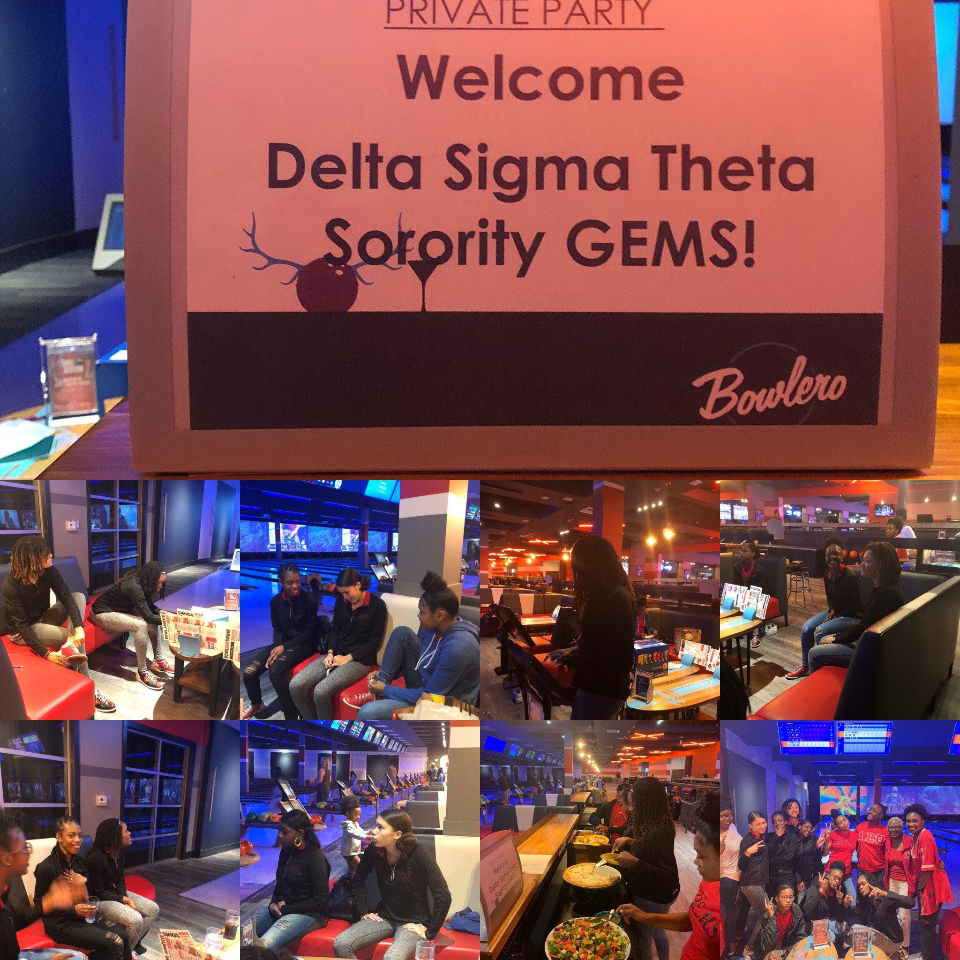  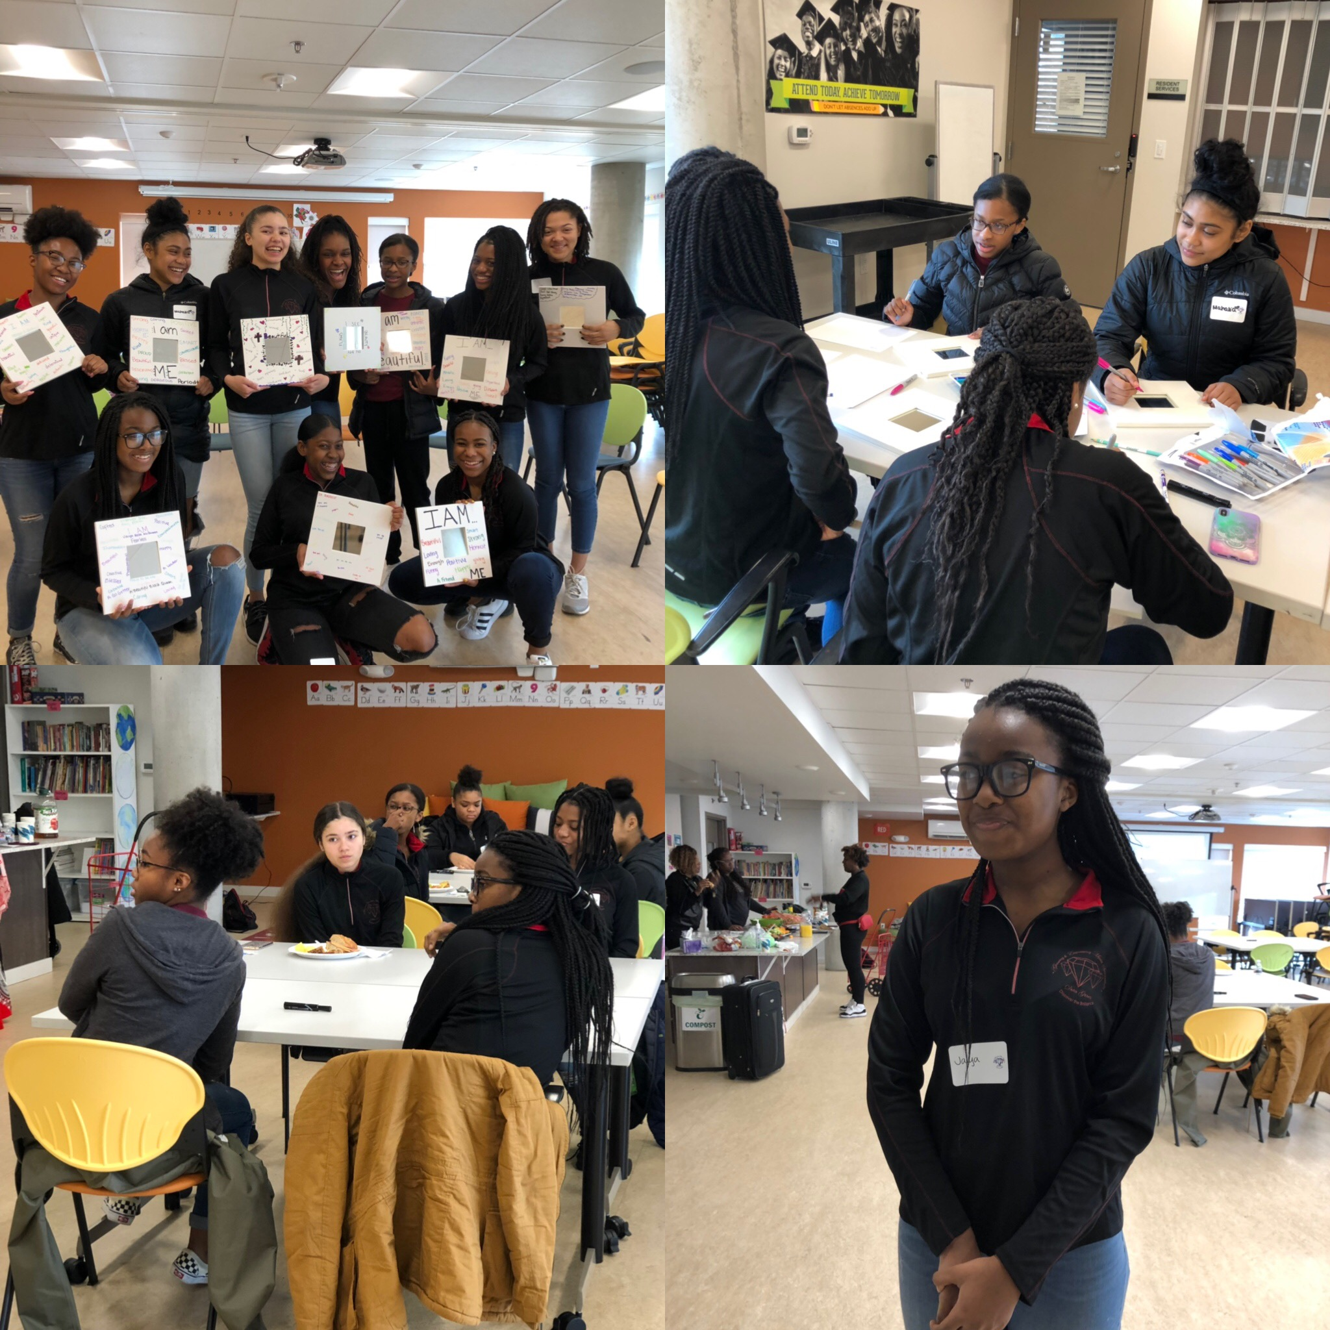  2017-19 GEMS

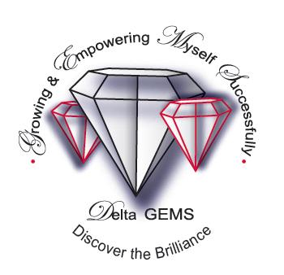The Dr. Jean L. Noble Delta G.E.M.S. supports young girls in 9th-12th grades  What are the goals of Delta Noble G.E.M.S.?  -To instill in our girls the need to excel academically  -To provide tools that will enable our girls to care for their mental, physical and emotional well-being  · To assist our girls in proper goal setting and planning for their futures—high school and beyond  · To create compassionate, caring and community-minded citizens | Delta Sigma Theta Sorority, Inc.  Founded January 13, 1913  Howard University- WA D.C.  Non-profit public service organization  1000 chapters in USA, Bahamas, Bermuda, England, Germany, Jamaica, Japan, Korea, Liberia, Nigeria, Virgin Is  Focus: 5 Point Program Thrust  Political Awareness & Involvement  International Awareness & Involvement  Educational Development  Economic Development  Physical & Mental Health  The members of the Seattle Alumnae Chapter pay ALL expenses. There are no extra charges for families. | Program Details  Sessions: Mercy Othello Plaza  6940 MLK Way So Seattle 98116  3rd Saturdays 10-noon  October-June  For 9th-12th grades girls  ****************************  G.E.M.S. program also include  Lunch  Black History mini-lessons  Theater or Movie Excursions  Exposure to women who are scientists, physicians, engineers, lawyers, managers and business owners  Open to all ethnicities & religious groups  Perform public service project  Seattle Alumnae Chapter  Delta Sigma Theta Sorority, Inc  PO Box 28046 Seattle 98118  info@seattledeltas.org  Applications @ www.seattledeltas.org  Beginning Aug 1-Sept 13

