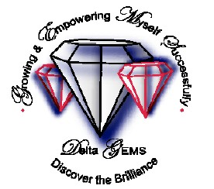
Delta Sigma Theta Sorority, Inc.
Seattle Alumnae Chapter
2020-2021 Dr. Jean L Noble Delta G.E.M.S. APPLICATION

Thank you for applying for the Dr Jeanne L. Noble GEMS program! GEMS is the acronym for Growing and Empowering Myself Successfully. It is named for the 12th national president of Delta Sigma Theta Sorority.

Seattle Alumnae Chapter (SAC) is one of a thousand chapters in the sorority, a public service, non-profit organization, founded in 1913 by 22 collegiate women at Howard University. SAC has served King, Kitsap and Snohomish Counties since 1933. For more information about our national and local organizations- go to www.deltasigmatheta.org and www.seattledeltas.org.

Goals: Interactive activities focusing on collaborative planning, leadership, and self-care; exposure to a variety of career options; planning for next school year or post-high school graduation; participating in public service activities, attending an Afro-centric play/movie, and award a GEM senior a college scholarship if she is attending a four year university & qualifies.

Eligibility: Attending a private or public high school; All races and religions welcomed.

When: The program meets every 3rd Saturday, 10 am- noon, October -June, at Mercy Othello Plaza, 6940 MLK Way South, 98118 All expenses are paid by SAC. All volunteers are trained and have approved background checks. If accepted, your first session will be October 17th. We will meet virtually until state guidelines change.

Checklist for Application Process
- Complete: REQUIRED PERSONAL DATA __ PARENT Application pgs. 1-15___
- SCHOOL INFORMATION __
- Tee-shirt/hoodie size ___ (very important-we order in Sept) Share Who You Are: ____

Incomplete applications cannot be considered for participation. Completed GEMS and PARENT applications are due on or before September 30, 2020. Applications postmarked or emailed after this date will not be considered.

Submit electronically or mail

Scan and Email to info@seattledeltas.org

NOTE: After the GEMS Committee reviews all of the applications, you will be notified once again if you are in the program or on a waitlist.

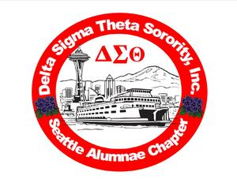
Delta Sigma Theta Sorority, Incorporated
Seattle Alumnae Chapter
2020-21 GEMS Program

REQUIRED PERSONAL DATA

Applicant Name: First Middle Initial Last

Home Address: City Zip Code

Applicant Contact Telephone:

Applicant Email Address:
Highlight Ethnicity (Optional):

African/African-American_ Asian/Pacific Islander Hispanic/Latino White Bi-racial

Tee-shirt/hoodie size

PARENT/GUARDIAN INFORMATION

Parent/Guardian Name:

Parent/Guardian Telephone: ( )
(circle if: cell or work)

Parent/Guardian Email address:

Emergency Contact/ Name and phone:
SCHOOL INFORMATION

High School Name:
Birth date:

Grade Level (circle): Freshman Sophomore Junior Senior Cum GPA:

Share a little bit about yourself
My friends think I am:

In my spare time, I:

I think school:
In ten years, I will:
I want to know more about:

My favorite tv shows are
Reading is
Math is
Writing is

Highlight all that apply:
I sing dance play a musical instrument write spoken word/poems/lyrics act
I am sort of shy/reserved outgoing focused More

My signature below certifies that the information on this application is complete and accurate. I understand that any misrepresentation may cause dismissal from the Seattle Alumnae Chapter Delta GEMS Program.

Applicant's Signature Date

My signature below certifies that I authorize my daughter's participation in the Seattle Alumnae Chapter
Delta GEMS Program and activities. I give/do not give (circle one) my permission for my daughter’s image to be used on Seattle Alumnae Chapter’s, Farwest Region’s or Delta Sigma Theta Sorority, Inc’s website, Facebook page and Twitter account. I will notify GEMS chairs at 206-992-8173 or info@seattledeltas.org if my daughter will miss a session.

________________________________________________________________________
Parent/Guardian Signature Parent/Guardian phone Emergency Contact Name and Number

